# Assignment 0: Evaluate your current company/client’s architecture by placing components in each of the areas for enterprise architecture solution.

Instructions:

1. Research and gather information about the current architecture of your company or client. This could include infrastructure, applications, databases, systems, processes, and workflows.
2. Using the areas for enterprise architecture solution, identify and classify each component of the architecture.
3. Create a visual representation of the architecture, placing each component in its respective area.
4. Analyze the architecture and identify any gaps or areas for improvement.
5. Develop recommendations for improving the architecture based on the identified gaps and areas for improvement.
6. Present your findings and recommendations in a clear and concise manner to stakeholders and decision-makers.

Areas for enterprise architecture solution:

1. Business architecture: Includes components related to the organization's goals, strategies, processes, and workflows.
2. Data architecture: Includes components related to data management, storage, and analytics.
3. Application architecture: Includes components related to software applications, including their design, development, and deployment.
4. Technology architecture: Includes components related to hardware and software infrastructure, network and communication technologies, and security.

By completing this assignment, you will gain a better understanding of your company or client's architecture and be able to identify areas for improvement to ensure that the architecture supports the organization's goals and objectives.

# Solution:

## Evaluate your current company/client’s architecture placing components in each of the areas:

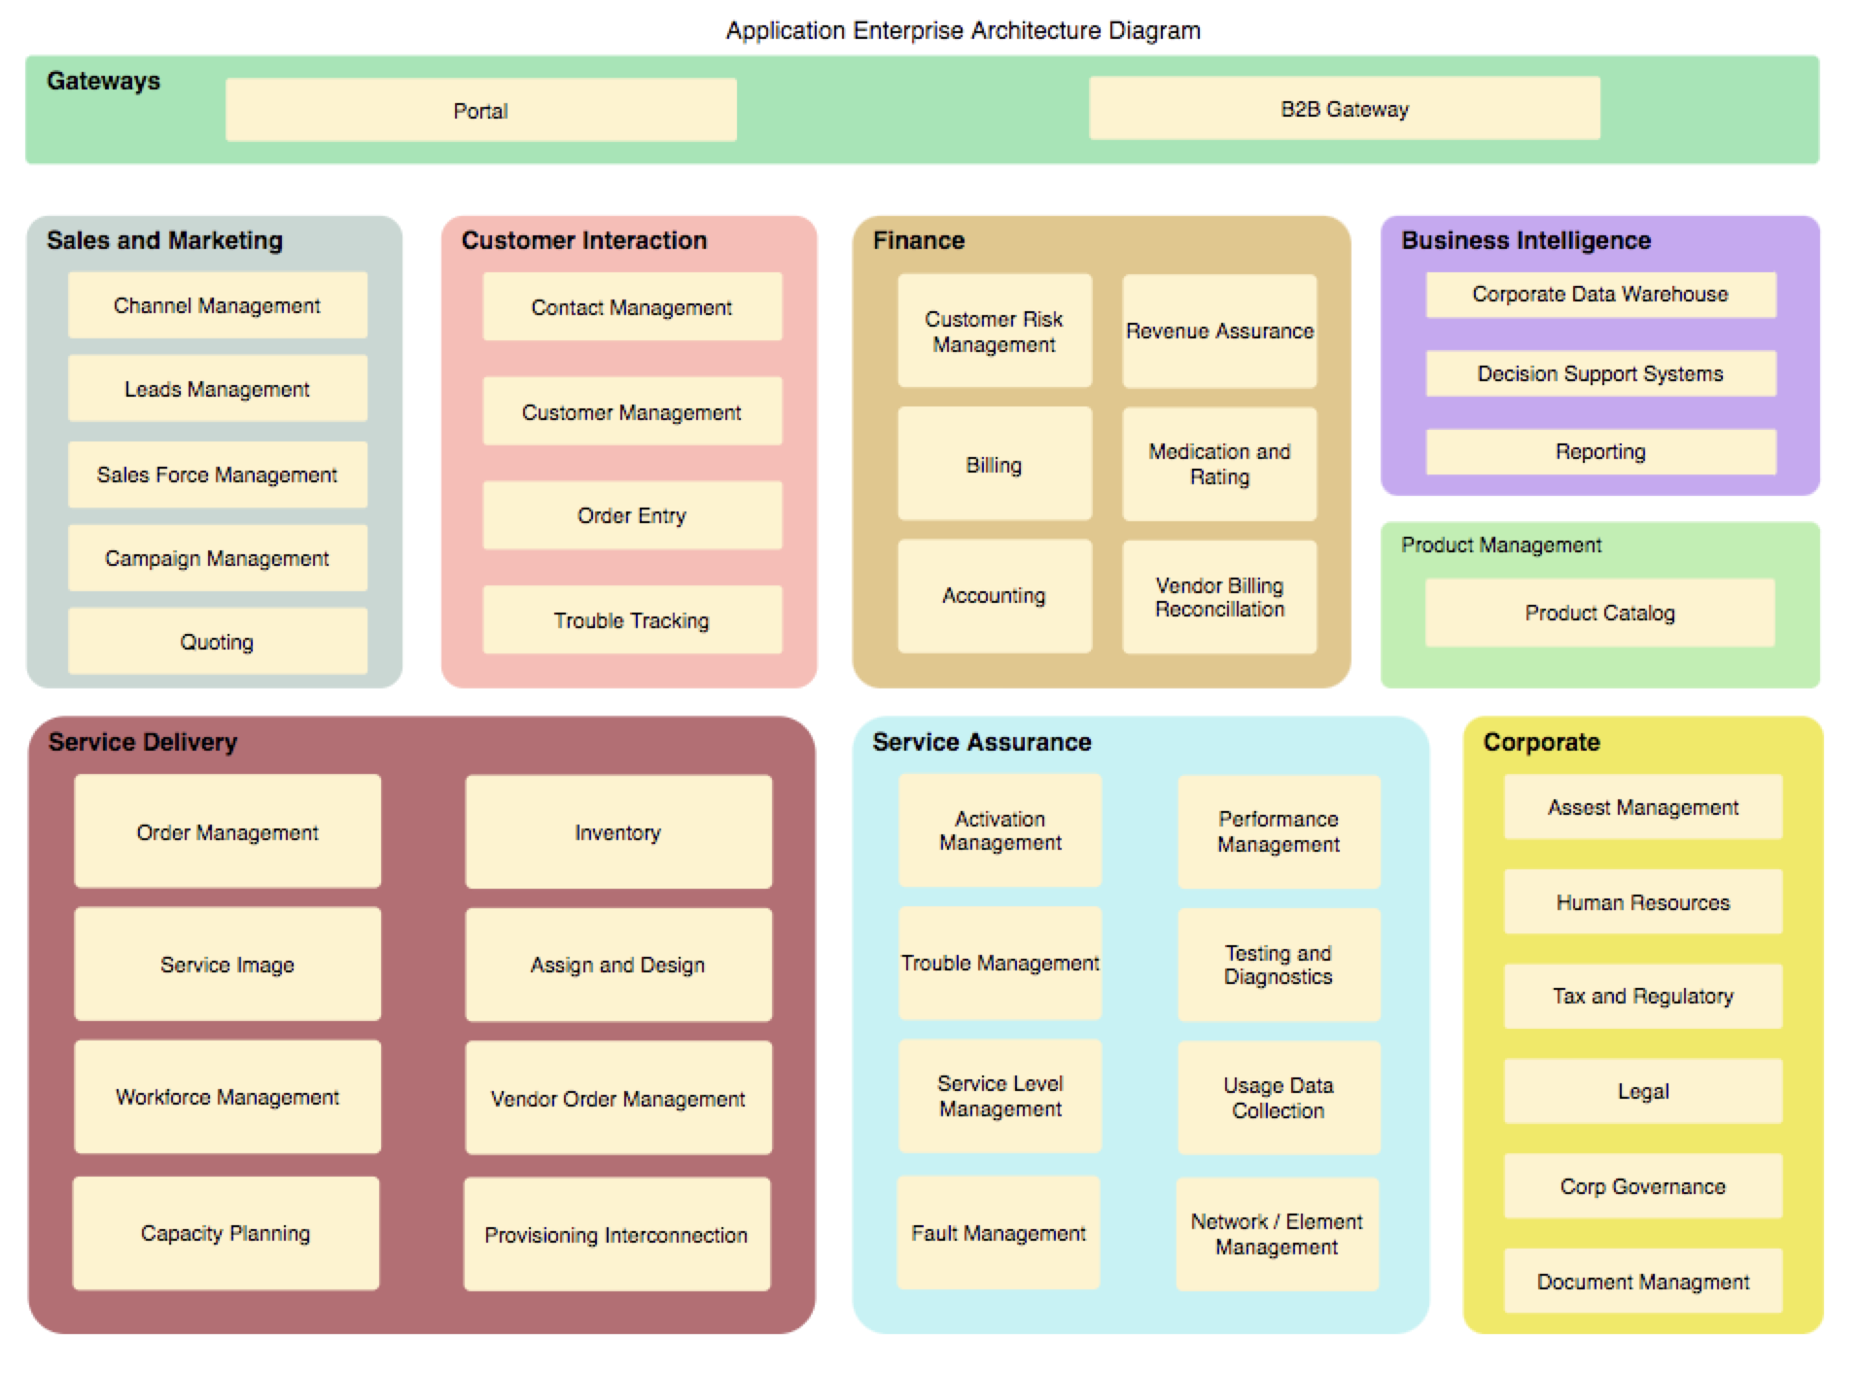

After researching and gathering information about the current architecture of the company, the components were classified into the following areas for enterprise architecture solution:

* Business architecture:
  + Mission statement
  + Vision statement
  + Organizational goals
  + Business processes
  + Workflow diagrams
* Data architecture:
  + Databases
  + Data storage systems
  + Data analysis and reporting tools
  + Data integration tools
  + Data governance policies
* Application architecture:
  + Web applications
  + Mobile applications
  + Desktop applications
  + Third-party applications
  + API services
* Technology architecture:
  + Servers
  + Network infrastructure
  + Cloud services
  + Security systems
  + Backup and disaster recovery systems

After analyzing the architecture, the following gaps and areas for improvement were identified:

* **Lack of integration between business processes and applications**
* **Insufficient data governance policies and procedures**
* **Inadequate backup and disaster recovery systems**
* **Limited use of cloud services for scalability and cost-effectiveness**

To address these gaps and areas for improvement, the following recommendations were made:

* Develop a comprehensive data governance policy to ensure that data is properly managed, secured, and analyzed.
* Integrate business processes and applications to improve efficiency and productivity.
* Implement a robust backup and disaster recovery system to ensure business continuity in the event of a disaster.
* Increase the use of cloud services to take advantage of scalability and cost-effectiveness.

## Weakest Link

## Identify the weakest link

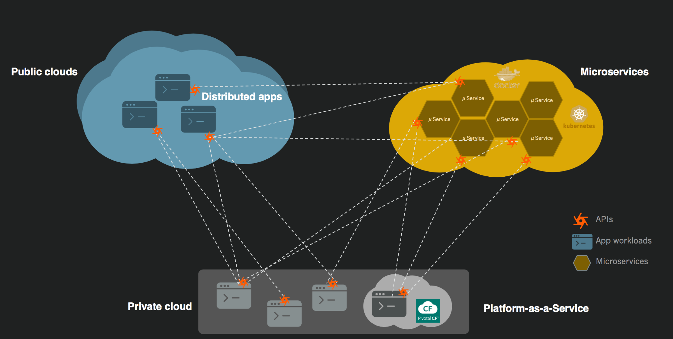

## 

1. Review each component of the architecture and its dependencies: To identify the weakest link in an architecture, it is important to review all the components of the architecture and the dependencies between them. This will help identify any potential vulnerabilities or risks.
2. Evaluate the performance and reliability of each component: Look for components that are not performing optimally or are not reliable. For example, if a database is frequently crashing, it may be a weak link in the architecture.
3. Analyze the security posture of each component: Look for components that have weak security controls or have not been properly configured. These could be potential weak links that could be exploited by attackers.
4. Evaluate the scalability and cost-effectiveness of each component: Look for components that are not scalable or are too expensive to operate. These could be potential weak links that could impact the ability of the architecture to meet the organization's goals.

## 

## 